No 7-12

Primary color

Buttons

Spacelessness central video – from youtbe

Background color for quote section

Update logo in the quote section

Carousel for the teams with the logo – color changes

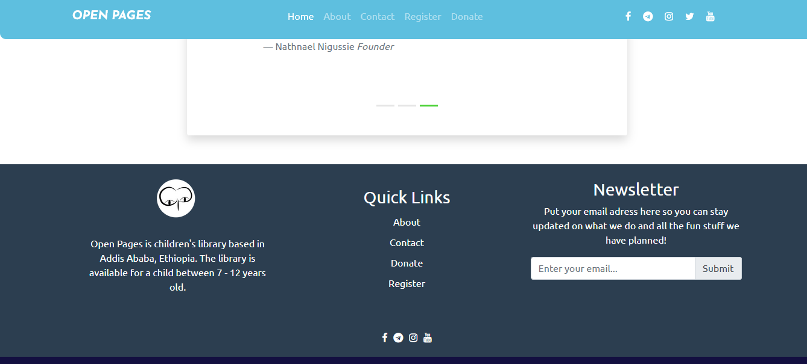

“tilet” in the upper side of the footer